Name:- Saiba Pathan
Roll_no:- 09
Div:- C

Lab – 08
Title: Logging to CloudWatch via CLI and OpenSearch
Objective:
To manually create a CloudWatch Log Group and Log Stream using AWS CLI, send a basic log message, and verify it in the AWS Console. This lab demonstrates CLI-based interaction with CloudWatch for enhanced visibility and control.

Duration:
Approximate time taken to complete the lab: 2 Hours

Pre-requisites:
- AWS Free Tier Account
- IAM Role with:
logs:CreateLogGroup
logs:CreateLogStream
logs:PutLogEvents
- EC2 instance (Amazon Linux 2) or AWS CloudShell
- AWS CLI (pre-installed)

Lab Steps:
Part A – Create a Log Group

Screenshot 1: CloudShell/EC2 terminal showing successful creation (or "ResourceAlreadyExistsException" if repeated)

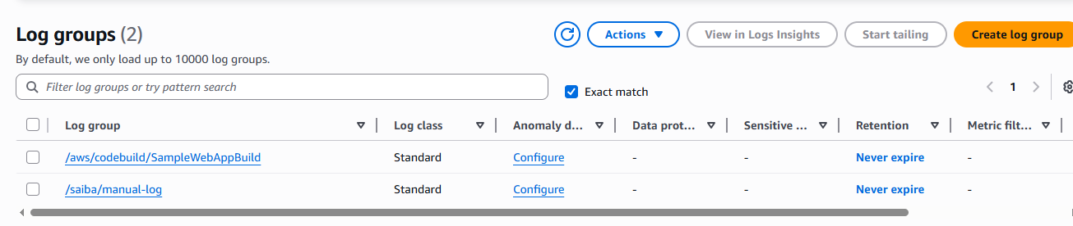

Part B – Create a Log Stream
📸 Screenshot 2: Confirmation of log stream creation
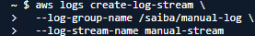

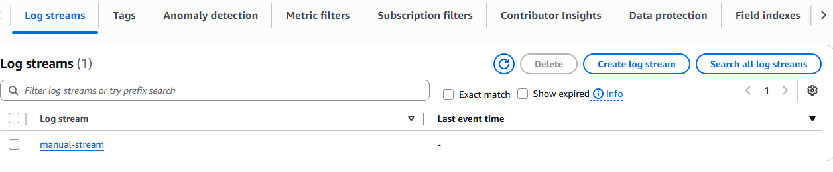
Part C – Send a Log Event

📸 Screenshot 3: Output showing nextSequenceToken from AWS CLI

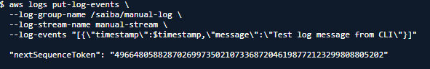

Part D – Verify Log in AWS Console
- Go to AWS Console → CloudWatch → Log Groups
- Open /ec2/manual-log → manual-stream
- Check that your log message appears
Screenshot 4: Log message displayed in the AWS CloudWatch console
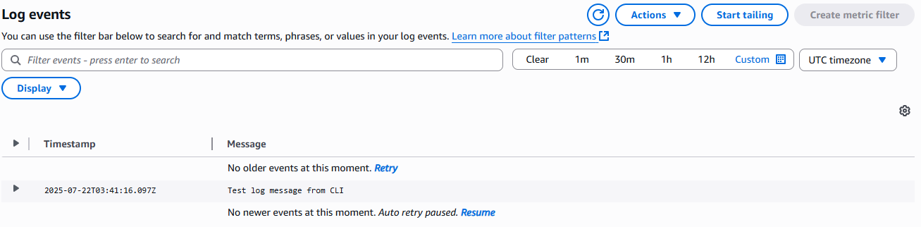
Observations / Challenges
- Got ResourceAlreadyExistsException when re-running log group creation → Safe to ignore
- Logs didn't show instantly in console → Waited a few seconds
- Important to use correct timestamp format in milliseconds
Instructor Remarks